**From EPAG Facilitator’s Tip Guide: July 2011 (DRAFT)**

**EPAG Team Approach**

**PLEASE NOTE:**

Starting in early August 2011, all service providers will conduct a literacy / numeracy assessment (with support from NAEAL) to identify each trainees’ educational level. After concluding this exercise, the service providers will be ready to introduce the “EPAG Team Approach.”

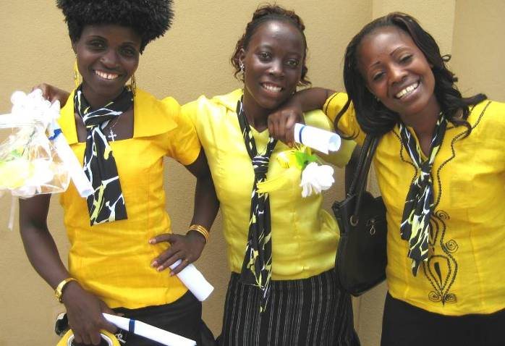**CONCEPT OF TEAMS:**

The “EPAG Team Approach” means that EPAG trainees will work in small groups to enhance their experience in the EPAG project, both inside and outside the classroom. Common sayings in Liberia that explain the team approach are:

* “Be your sister’s keeper.”
* “Each one, keep one.”

**OVERVIEW:**

“EPAG Team” is the new name for the “pairs / small groups” used during Round One. Please note that the EPAG Teams continue throughout the entire Round Two implementation period, through June 2012.

Following the EPAG Team Approach strategy, the girls will be grouped into teams of three to four girls. The groupings will be done jointly by the girls and their trainers. The girls will be counseled to pick other girls who are not necessarily their best friends. Using the results of the literacy / numeracy assessment, the trainers will help to mix skill-levels within the groups—i.e. mix someone who is strong in reading and writing with someone who is not. When possible, team members should be within similar age-ranges and live near one another.

During Round One, the pairing / small group approach was one way the trainers were able to cope with the widely varied learning levels in their classrooms. Because they purposefully grouped girls with mixed educational backgrounds together, the trainees were able to help one another learn. The “exit poll” conducted during Round One found the pairing / small group approach to be an effective training technique. The positive peer pressure between the groups helped to push the attendance rates up during the classroom training phase. Outside the classroom, there were numerous accounts of group members helping one another. For example, in a few cases when a trainees’ home was flooded, burned, or she was evicted, her group members took it upon themselves to secure new housing for her. There are also stories about group members visiting one another in the hospital or taking care of one another’s children. During the placement phase, the pairs / small groups continued to support one another, in some cases even forming cooperative businesses ventures.

The team approach is not without its challenges, however. In Liberia, educational level is often a marker of social status. During Round One, trainers sometimes had to mediate “big egos,” for example, when a high school graduate was grouped with three school dropouts.

|  |  |  |
| --- | --- | --- |
| **SAMPLING OF COMMITMENTS: ROUND ONE** | | |
| Each member of the group is responsible for the group members’ attendance.  **Sisters of Success**, Old Road | Promise to extend our friendship even after the training.  **Amigo Friends Forever**,  Bassa Community | Support each other during stressful moments; Study together after class.  **Divine Sisters**, West Point |
| Love each other as long as we live; Always visit each other at home to find out how everyone is doing.  **Kind & Lovely Sisters**,  Doe Community | Be our sisters’ keeper; Not gossip about each other.  **Ladies of Prosperity**, Kakata | Make sure we know each others’ houses; Respect each others’ views.  ***Kuka Tonor* (We Are One)**,  New Kru Town |

**WHY USE TEAMS?**

This approach is based on the following objectives:

1. To promote girls’ safety – traveling together to and from training, and mutual support to thwart sexual exploitation and abuse and other issues that threaten their safety, etc.
2. To improve girls’ performance in the training – jointly reviewing and helping each other with lessons and homework materials, managing workloads, encouraging one another to attend classes, etc.
3. To establish social assets (friends, access to networks, etc.) – balancing their competing priorities, mutually managing daily stresses and challenges such as childcare, etc.

EPAG TEAM APPROACH LESSON PLAN:

Below are three activities EPAG trainers can use in the classroom to form the EPAG Teams. This lesson plan was developed by IRC Liberia for the EPAG project. It has been adapted for this guide. Trainers can further adapt this lesson plan and add on to it.

REMEMBER: You should complete the literacy / numeracy assessment before you introduce the team approach. The assessment will help you to gauge the educational level of each trainee. This will be useful to know when you are creating the teams so that we can better mix the higher level learners with the lower level learners.

**Learning objectives:**

At the end of this three-part lesson, participants will:

* Form teams of 3-4 girls
* Make specific commitments within their teams

ACTIVITY 1:

United We Stand, Divided We Fall

**TIME:** 45 minutes

**MATERIALS:** None

**Facilitation steps:**

1. Explain to the participants that we’re going to play a game. Divide participants into groups of five or six.
2. Ask each group of five or six to stand in a small, tight circle. Then ask for a volunteer from each small group to stand in the middle of each circle. Tell the groups that the volunteer will close her eyes and then fall – backwards, forwards, or sideways – keeping her eyes closed. It is the job of the circle to safely catch the volunteer and prevent her from falling to the ground!
3. When everyone is ready, tell the volunteers to close their eyes and fall! Make sure that the people in the circle catch her in their arms. It can feel quite scary at first but should be perfectly safe provided the group works together.
4. Make sure each girl in the group has a chance at being in the middle and falling.
5. After everyone has had a chance to be in the middle, tell participants to take their seats. Discuss the following questions:
   * How did it feel to be the person in the middle falling? Was it scary? Did you trust the others to catch you?
   * What would have happened if there were no people in the circle to catch you?
   * How did it feel to be the person in the circle catching your friend? Did it feel like a lot of responsibility? Did you feel confident you could catch her?
   * What do you think the game was about? (Suggested answers: trusting each other, working together, keeping each other safe and out of harm’s way)
   * What did the game teach you? (Suggested answers: it is important to be able to trust your friends, your friends can keep you from falling or failing)
6. Summarize the discussion by saying that in life, we can sometimes feel like the blind person in the middle of the circle falling. There are many challenges and obstacles in life that can make us feel confused and unsure of what to do. These obstacles can make us fall, or fail to achieve success. If we did not have people in our life to support us, we would fall to the ground. The game showed us that having people in our life that we can trust to support us means that even when we are at risk of falling, there will be a safety net to keep us going.
7. Explain the idea of “united we stand, divided we fall.” Explain that everyone is going to form small teams that will support each other to succeed in this training. Tell the participants that they will stay in these teams during the classroom training and even throughout the business and job placement phase. These teams will be like the circle that will help them succeed.

ACTIVITY 2:

Choosing Our Teams

**TIME:** 45 minutes

**MATERIALS:** None

**Facilitation steps:**

1. Ask participants what “Be Your Sister’s Keeper” and “Each One, Keep One” mean to them.
2. Ask participants what challenges or obstacles they think they might face in successfully completing the training. (Suggested answers: dropout due to loss of interest, poor attendance due to other tasks, difficulty in balancing other responsibilities, harassment from people in the community on the way to class, not understanding the training content, falling behind on homework, etc.)
3. Explain that the participants are likely to face different challenges to successfully completing the classroom training and starting their business or job. In addition to the support provided by the trainers, the best people to support them are their fellow participants! The purpose of forming teams is to support each other to succeed in the project.
4. Explain to participants that they will now form teams. Emphasize that they will stay in these teams for the remainder of the project.
5. Explain carefully the following criteria for forming teams:
   * Each team should be made up of 3-4 girls
   * Team members should have different skill levels (e.g. mixture of high and low literacy, mixture of a lot of business experience with little business experience, etc.). This is to ensure team members can help each other
   * Team members should NOT necessarily be your close friends already
   * Team members should be about the same age
   * Team members should live near each other
6. After making sure all the participants understand the purpose of the teams and the criteria for forming their teams, give them about 20 minutes to form the teams.

**Facilitator’s note:**

During this time, trainers should be helping participants form the teams. It is your job to ensure the criteria are followed as much as possible.

It is very important that the learning levels are mixed within each team, as this will make your job easier. How? The higher level learners in each group will be able to help you teach the lower level learners in each group.

1. By the end of the activity, all participants should be in small teams that they feel comfortable with.

ACTIVITY 3:

Our Commitments to Our Teams

**TIME:** 1.5 hours

**MATERIALS:** Ream of sheets or poster sheets, markers

**Facilitation steps:**

1. Congratulate participants on successfully forming their teams! Remind them that they will act as a support circle for each other during the EPAG project to ensure that they all succeed.
2. Explain that now that they have formed their teams, the next step is to come up with a name for their team. Remind participants that these names should be positive and empowering – give an example like “Success Sisters.”
3. Tell participants that after coming up with a name for their team, the next step is to come up with a list of commitments that they will make to each other. Tell them that the commitments they make to each other will enable them to support each other to succeed in this training and in life.
4. Give participants some of these examples, but encourage them to come up with more!

* Making sure team members always attend class on time
* Helping each other with assignments
* Studying together after class
* Visiting each other at our houses
* Supporting each other during stressful times

1. Tell participants to sit in their teams and start brainstorming their team name and team commitments. Ask them to take a piece of paper or poster sheet and write their team name at the top, the names of the team members, and the commitments they will make to each other.

**Facilitator’s note:**

During this time, go around the teams and help them brainstorm commitments. Help with spelling and writing if necessary.

1. When all the teams are finished, ask for volunteers to present their team name and team commitments. During the presentations, encourage teams to add more commitments to their list if they think of more. Each team should have at least 3 commitments.
2. Wrap-up by explaining that you’ll be doing follow-up over the next few weeks and months to see how the teams are working and if they are sticking to their commitments. Emphasize the importance of using their team members as a support system to enable each member to reach her maximum potential in the EPAG project.

1. Collect the sheets of paper or poster sheets with the team names, team members, and team commitments written on them. Explain that you will be making copies for your records and that you will return the originals to the groups at the next session. It is a good idea to post the team commitments on the classroom walls.